Automated Virtual SOC Environment
Project Introduction & System Architecture
Mostafa Badawy Mohamed
2025/2026

1. What Is This Project? (The Simple Version)

Imagine you are the security guard of a large building. Your job is to:
- Watch every door and window all day and all night.
- Identify suspicious visitors before they enter.
- Lock certain doors automatically when a threat is spotted.
- Send a message to your phone every time something important happens.
- Write a report for every serious incident.

This project builds exactly that — but for a computer network instead of a building.

One-line summary:
A fully automated digital security guard that watches a network, detects attacks, blocks threats, and alerts the analyst — all without any human clicking a button.

2. Why Was It Built?

Real Security Operations Centers (SOCs) use very expensive software. A single commercial license can cost tens of thousands of dollars per year. Most universities and small businesses simply cannot afford that.

This project proves that you can build a fully working SOC using only free, open-source tools and still get the same results.

The Problem  Enterprise SOC software is too expensive for most schools and small teams. Students learn theory but never practice with real tools. | The Solution  Build a complete SOC using only free tools that runs on a single laptop. Full detection, enrichment, blocking, and alerts — zero cost.

3. The Tools — What Each One Does

Think of the system as a team of specialists. Each tool has one specific job:

Tool | Role in the Team | Simple Analogy
Security Onion + ELK | Collects & stores all network events | The CCTV system that records everything
Zeek | Reads network traffic | A traffic officer reading every car's plate
Suricata | Detects attack patterns | A guard dog that barks at suspicious behaviour
ElastAlert | Watches stored events for rule matches | An alarm that triggers when a rule is broken
n8n | Runs the automated response workflows | The control room that decides what to do next
AbuseIPDB / VirusTotal / GreyNoise | Check if an IP or URL is known malicious | Checking a visitor against a criminal database
TheHive | Creates and manages incident cases | The incident log book
FortiGate | Blocks threats at the network level | The bouncer who removes the threat
Telegram / Gmail | Sends instant alerts to the analyst | A text message straight to the analyst's phone

4. System Architecture — How Everything Connects

The system is structured in four layers. Data moves upward from the network to the analyst. Before reading the layers, it helps to understand the physical setup: some components run directly on the host machine, while others run inside virtual machines — all connected on the same private network.

LAYER 4 — ANALYST LAYER
Telegram Bot + Gmail + TheHive Cases
The SOC Analyst receives real-time notifications and structured case reports.
▲
LAYER 3 — AUTOMATION & RESPONSE LAYER
n8n Workflows + AbuseIPDB / VirusTotal / GreyNoise / URLScan.io + FortiGate REST API + TheHive API
Three automated workflows enrich indicators, score risk, block threats, create cases, and send notifications.
▲
LAYER 2 — DETECTION & ALERTING LAYER
Elastic Stack (Elasticsearch + Kibana) + ElastAlert
Stores all security events, visualizes them in dashboards, and triggers alerts when detection rules match.
▲
LAYER 1 — DATA COLLECTION LAYER
Security Onion + Zeek (network traffic) + Suricata (intrusion detection)
Captures all raw network traffic, analyzes packets, and generates security events.
▲ Network Traffic ▲

4.1 Physical & Virtual Infrastructure
The four logical layers described above are physically deployed across two environments: a host machine running Docker containers, and a VMware Workstation hypervisor hosting four virtual machines. Every component — physical and virtual — communicates over the same isolated private network: 192.168.5.0/24 (VMnet).
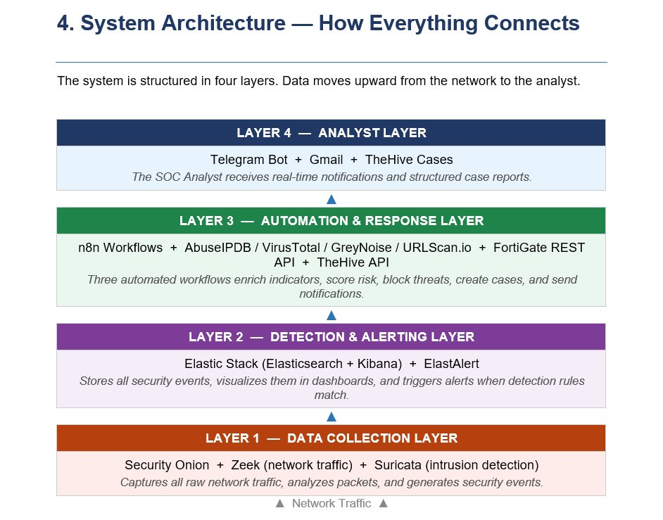
Figure 1 — The four-layer architecture as seen from the analyst’s perspective

Where Each Component Lives
Environment | Component | IP Address | Role
Host Machine (Docker) | n8n (automation engine) | Host IP: 5678 | Receives alerts, runs all 3 workflows, calls external APIs, blocks threats
Host Machine (Docker) | TheHive (case management) | Host IP: 9000 | Stores all automatically created incident cases with enrichment data
VMware VM | Security Onion 2.4 (Zeek + Suricata + ELK + ElastAlert) | 192.168.5.50 | Sniffs all network traffic, stores events in Elasticsearch, fires ElastAlert rules
VMware VM | Kali Linux (attacker simulation) | 192.168.5.40 | Runs attack tools (hydra, nmap) to simulate real-world threats against the network
VMware VM | Windows 10 (victim endpoint) | 192.168.5.10 | Simulates a corporate endpoint that receives attacks and generates Windows Event logs (Filebeat)
VMware VM | FortiGate VM64 (next-gen firewall) | 192.168.5.20 | Enforces blocking decisions received from n8n via REST API — acts as the network’s last line of defence
All VMs are connected to a single VMware NAT network (VMnet8, 192.168.5.0/24). The host machine’s Docker containers reach the VMs via the same VMnet adapter, so every component can talk to every other component on this one internal network — with no external internet access required for the core detection pipeline.

How Components Talk to Each Other
Every connection in the project follows one of three patterns — a webhook push, an HTTP API call, or a network protocol (SSH/DNS). The table below traces every real connection in the system:
From | To | Method | What is sent & why
Zeek / Suricata (Security Onion) | Elasticsearch (local, same VM) | Internal write | All detected network events and alerts are written directly into Elasticsearch on the same Security Onion VM in real time
Windows 10 Endpoint | Security Onion (Elasticsearch) | Filebeat (TCP 9200) | Filebeat agent on the Windows VM ships Windows Event logs (Event ID 4625 brute-force attempts) directly into the filebeat-windows-* index on Security Onion at 192.168.5.50:9200
ElastAlert (Security Onion) | n8n Webhook (Host, port 5678) | HTTP POST (JSON) | When an alert rule matches, ElastAlert sends a JSON payload containing the attacker IP (or DNS domain) to n8n’s webhook URL. This single HTTP POST is what starts the entire automated response chain
n8n (Host Docker) | Security Onion Elasticsearch | HTTPS REST (9200) | n8n queries Elasticsearch (192.168.5.50:9200) to check for duplicate blocked IPs and to retrieve unprocessed phishing emails. Uses a manually built Authorization header (base64) because Security Onion uses HTTPS with a self-signed certificate
n8n (Host Docker) | AbuseIPDB / VirusTotal / GreyNoise / URLScan.io | HTTPS REST (Internet) | n8n sends the attacker’s IP or suspicious URL to four global threat intelligence databases simultaneously. The results are merged into a single risk score before any blocking decision is made
n8n (Host Docker) | FortiGate VM64 (192.168.5.1) | HTTPS REST API (443) | When blocking is needed, n8n calls FortiGate’s REST API using a dedicated admin account (n8n_api). It creates an address object for the threat and applies a deny firewall policy — all in seconds, with no human interaction
n8n (Host Docker) | TheHive (Host Docker, port 9000) | HTTP REST API | n8n creates a new incident case in TheHive on the same host machine (localhost:9000) containing all enrichment data, severity level, and an investigation task for the analyst
n8n (Host Docker) | Telegram Bot + Gmail (Internet) | HTTPS (Internet) | The final step of every workflow: n8n sends a formatted HTML alert to the analyst’s Telegram and Gmail simultaneously. The analyst’s phone buzzes within seconds of the original attack being detected
Picture the full scenario: A Kali Linux VM at 192.168.5.x runs a brute-force tool against the Windows 10 VM. Suricata, running inside Security Onion at 192.168.5.50, detects the attack pattern and writes the event to Elasticsearch. ElastAlert, also running inside Security Onion, notices the event matches a rule, and fires an HTTP POST to the n8n Docker container on the host machine. n8n extracts the attacker’s IP, queries AbuseIPDB and VirusTotal on the internet, calculates a risk score, then calls FortiGate’s REST API at 192.168.5.1 to create a deny policy. In parallel, it creates a case in TheHive on the same host machine and sends an alert to Telegram and Gmail over the internet. The entire chain — from the first failed login to the firewall block and the analyst’s phone notification — completes in under 30 seconds.

5. How Data Flows Through the System

Here is the complete journey of a security event from the moment an attack starts to the moment the analyst's phone buzzes:

Step | Component | What Happens
1 | Zeek + Suricata | Network traffic is captured and analyzed in real time. Attack patterns are detected.
2 | Elasticsearch | All security events are stored and indexed for fast searching.
3 | ElastAlert | Continuously checks stored events against detection rules. When a rule fires, it sends an alert.
4 | n8n Webhook | Receives the alert payload from ElastAlert. The correct workflow starts automatically.
5 | Duplicate Check | Elasticsearch is queried: has this indicator been actioned before? If yes, only a notification is sent.
6 | Threat Intel APIs | The indicator (IP or URL) is sent to AbuseIPDB, VirusTotal, GreyNoise, and/or URLScan.io.
7 | Risk Scoring | All API responses are merged and a composite risk score is calculated.
8 | Response Actions | High risk: block via iptables or FortiGate. Create TheHive case. Low risk: false positive notification.
9 | TheHive | A structured case is created with full enrichment data and an investigation task for the analyst.
10 | Telegram + Gmail | The analyst receives an instant notification with all relevant details within seconds.

6. The Three Automated Workflows

The heart of the system is n8n — an automation tool that runs three independent workflows. Each workflow handles a different type of threat completely automatically.
Workflow 1 — IP Threat Intelligence & Incident Management

What triggers it?
An external attacker is detected trying to brute-force into the network from outside. ElastAlert fires and sends the attacker's IP to n8n via webhook.
Step-by-step flow:
# | Step | What Happens
1 | ElastAlert fires | Suricata detects SSH brute-force — alert forwarded to WF1 webhook
2 | Extract & filter IP | Attacker's public IP extracted — private RFC1918 addresses discarded
3 | Duplicate check | Elasticsearch queried: IP already blocked? If yes — Repeat Attacker alert sent, workflow stops
4 | Initial Telegram alert | Analyst notified: 'Investigation started for IP X.X.X.X'
5 | Parallel enrichment | AbuseIPDB + VirusTotal + GreyNoise queried simultaneously
6 | Risk score calculated | Composite score 0–100 based on all three API results + Tor node status
7a | HIGH RISK — block | iptables block applied on Security Onion host
7b | HIGH RISK — record | Blocked IP written to Elasticsearch for future duplicate suppression
7c | HIGH RISK — case | TheHive case created with full enrichment report + investigation task
7d | HIGH RISK — alert | Full SOC alert sent via Telegram + Gmail
8 | LOW RISK | False positive notification sent — no enforcement action taken
WF1 Screenshots: 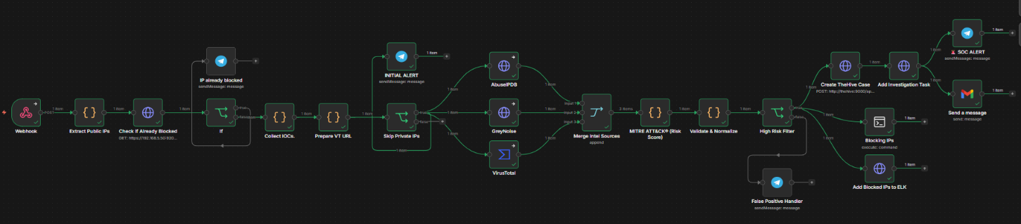
Telegram Initial Alert — Investigation Started: 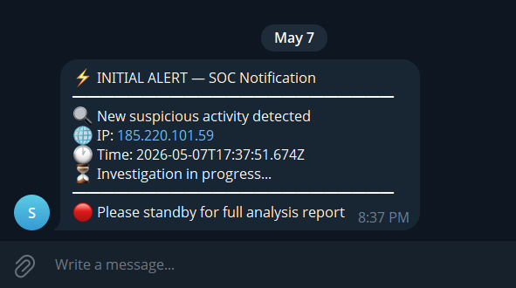
Telegram Full SOC Alert — High Risk Confirmed: 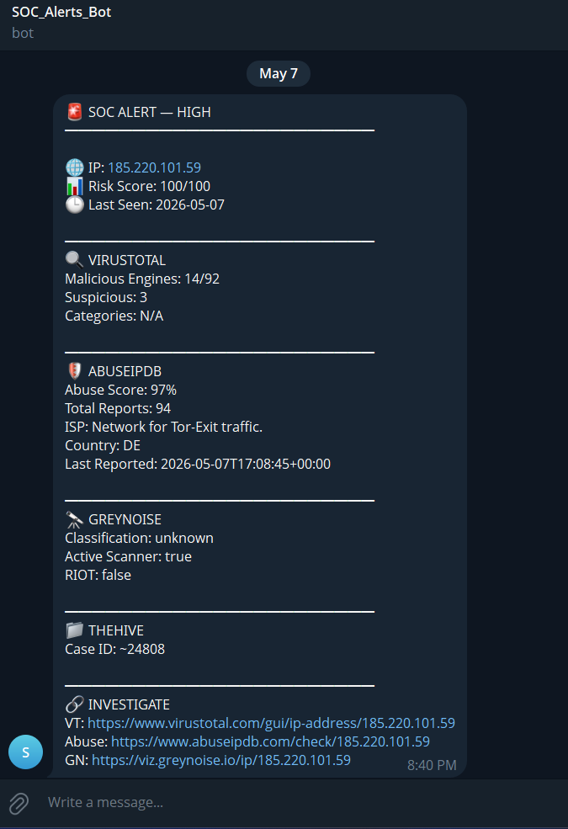
Gmail SOC Alert:
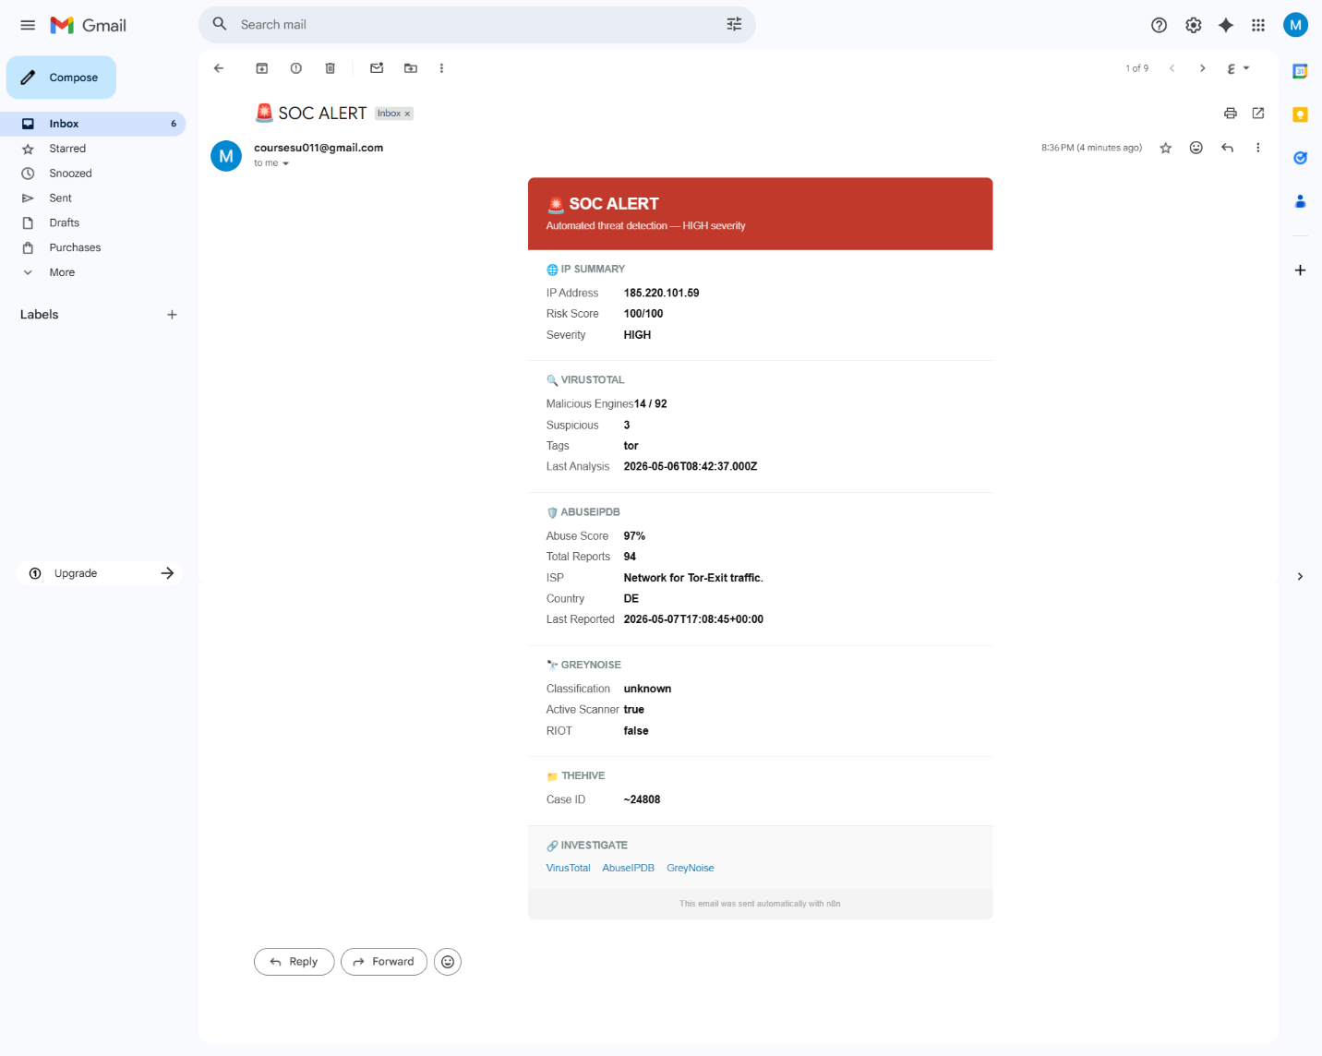

TheHive Case — Created Automatically:
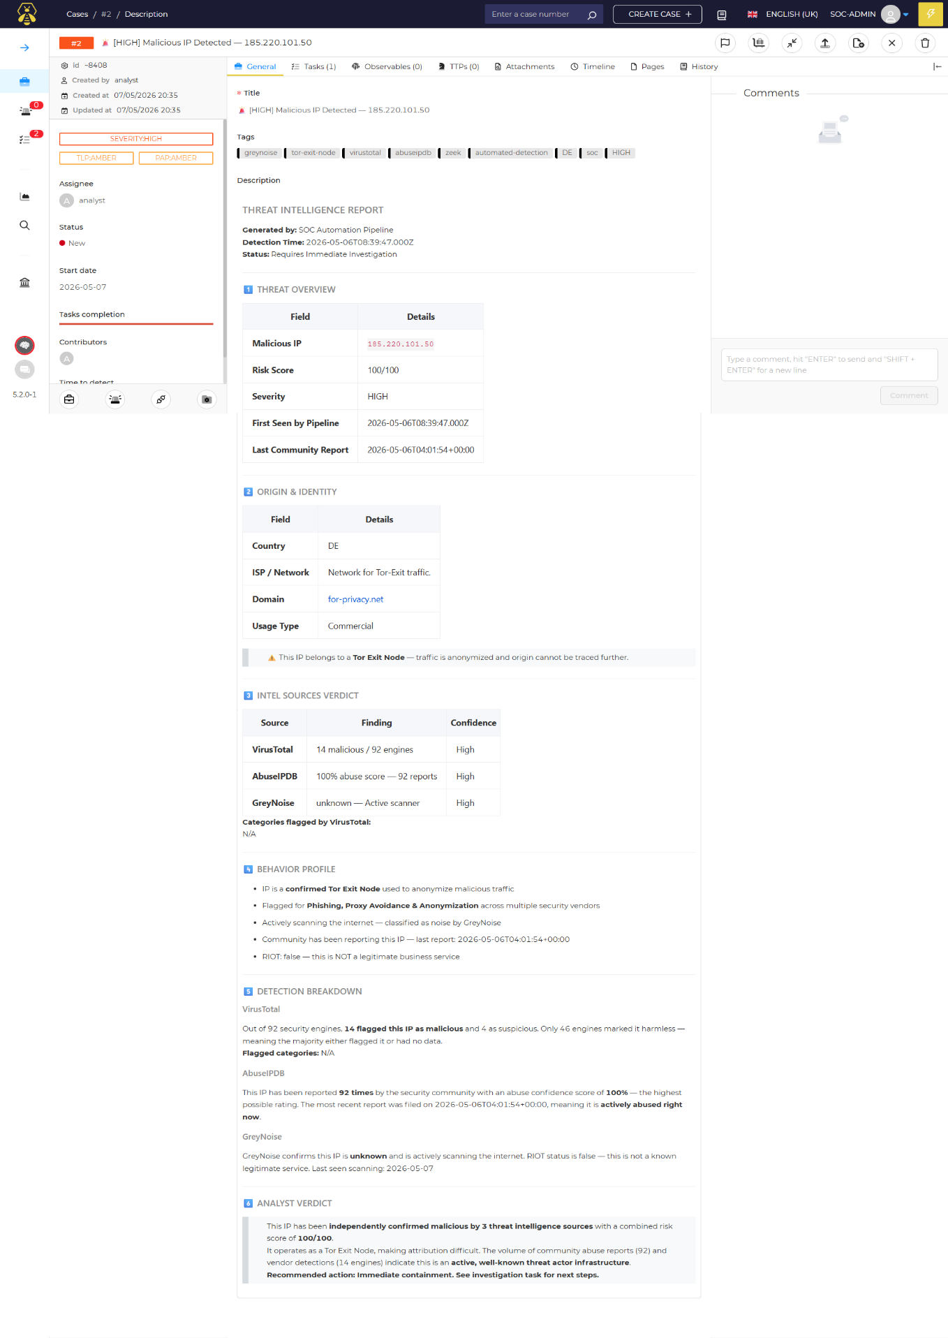
Telegram — Repeat Attacker Alert (Duplicate Suppression): 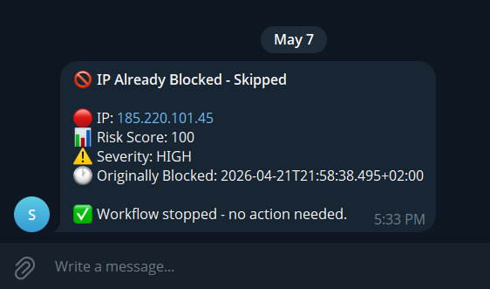
Telegram — Fulse positive Alert
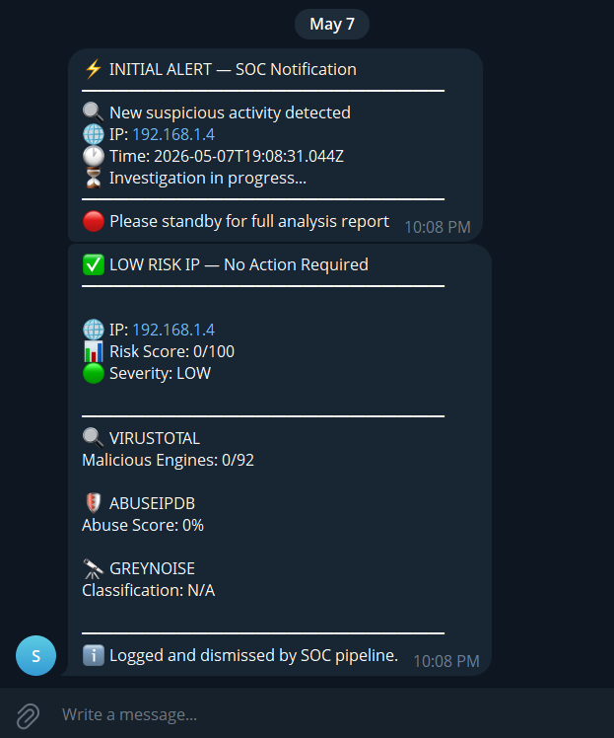
Workflow 2 — Phishing Email Detection

What triggers it?
A scheduled timer runs every few minutes and checks stored emails in Elasticsearch for phishing indicators. No manual action required.

Step-by-step flow:
# | Step | What Happens
1 | Scheduler fires | Timer triggers WF2 — HTTP POST retrieves unprocessed emails from Elasticsearch
2 | Split emails | Each email becomes a separate processing item
3 | Validate + clean | Required fields checked — HTML and non-ASCII removed
4 | Phishing detection | Heuristic check: urgency keywords ('verify','suspend','reset'), URL shorteners (bit.ly, tinyurl), redirect links
5 | URL enrichment | Flagged URLs sent in parallel to VirusTotal + URLScan.io
6 | Wait + retrieve | Wait node allows URLScan.io time to process — full scan result retrieved
7 | Merge all data | VirusTotal result + URLScan.io result + original email merged into one record
8 | TheHive case | Case created: sender, IOCs, detection reasons, VT results, URLScan.io link — severity HIGH
9 | Analyst notified | Telegram + Gmail Phishing Alert sent simultaneously

WF2 Screenshots:

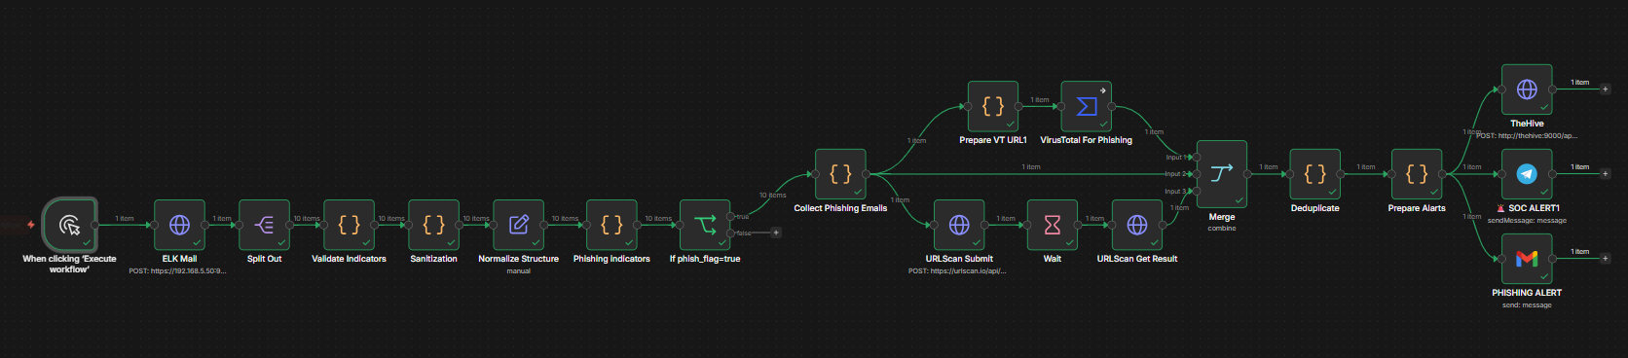

TheHive Case — Phishing Email Confirmed:
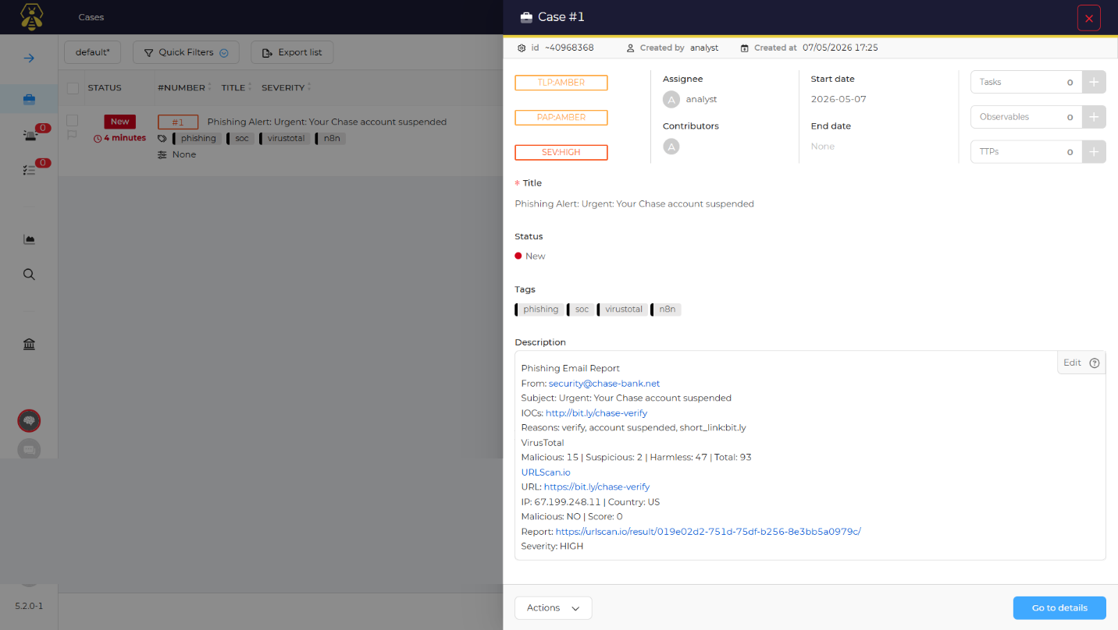

Telegram Phishing Alert:
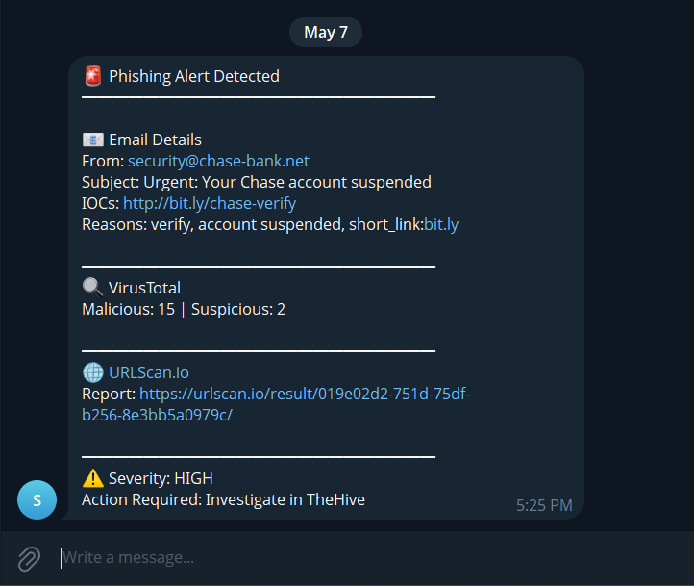

Gmail Phishing Alert:
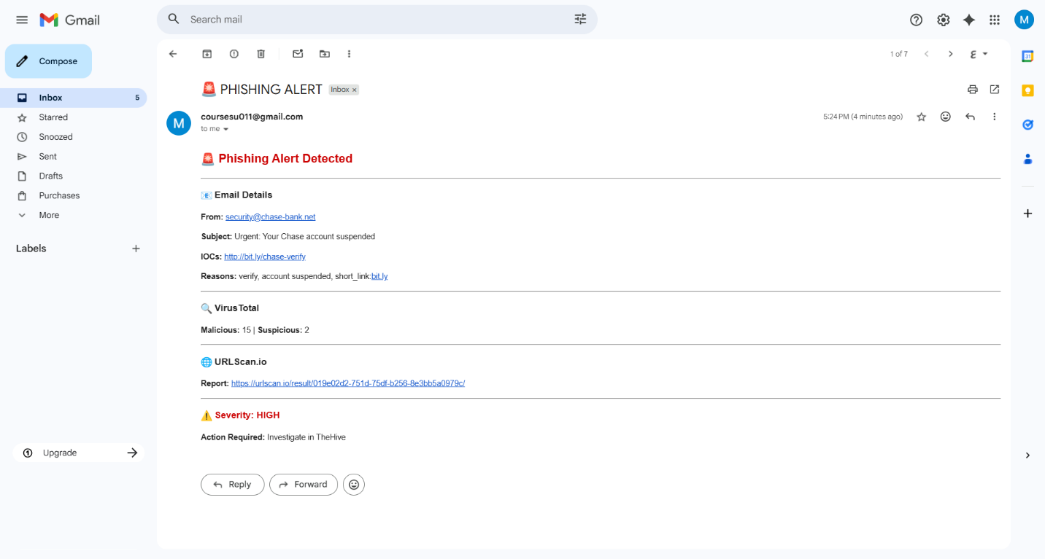
Workflow 3 — Endpoint Isolation & Malware Containment

What triggers it?
An internal computer on the network is either attacking other machines (SSH brute-force) or downloading malware (resolving malware domains via DNS). ElastAlert fires and the endpoint is isolated immediately.

Path A — Malware Domain Download:
# | Step | What Happens
1 | DNS alert fires | Zeek captures internal endpoint resolving a malware domain — ElastAlert triggers WF3 with DNS domain field
2 | Domain path selected | Alert Type branch detects DNS domain field — malware containment path entered
3 | VirusTotal check | Domain submitted to VirusTotal for verdict
4a | MALICIOUS — FortiGate block | n8n calls FortiGate REST API — address object created + deny policy applied for the domain
4b | MALICIOUS — alert sent | Telegram + Gmail MALWARE DETECTED alert confirms isolation applied
5 | CLEAN — no action | File Clean notification sent — no enforcement taken

Path B — Internal SSH Brute-Force:
# | Step | What Happens
1 | SSH attack alert fires | Suricata detects internal endpoint brute-forcing other hosts — ElastAlert triggers WF3 with source IP
2 | Network attack path selected | No DNS domain field — network attack isolation path entered
3 | Duplicate check | Elasticsearch queried: endpoint already blocked on FortiGate? If yes — Repeat Attacker alert sent
4 | FortiGate isolation | n8n calls FortiGate REST API — IP address object created + deny policy applied
5 | Alert sent | Telegram + Gmail NETWORK ATTACK DETECTED alert confirms endpoint isolated

WF3 Screenshots:
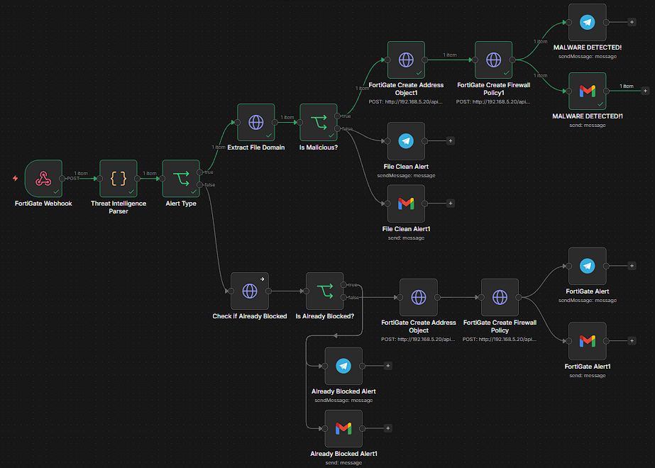
Kibana — Malware Download Alert (High Severity):
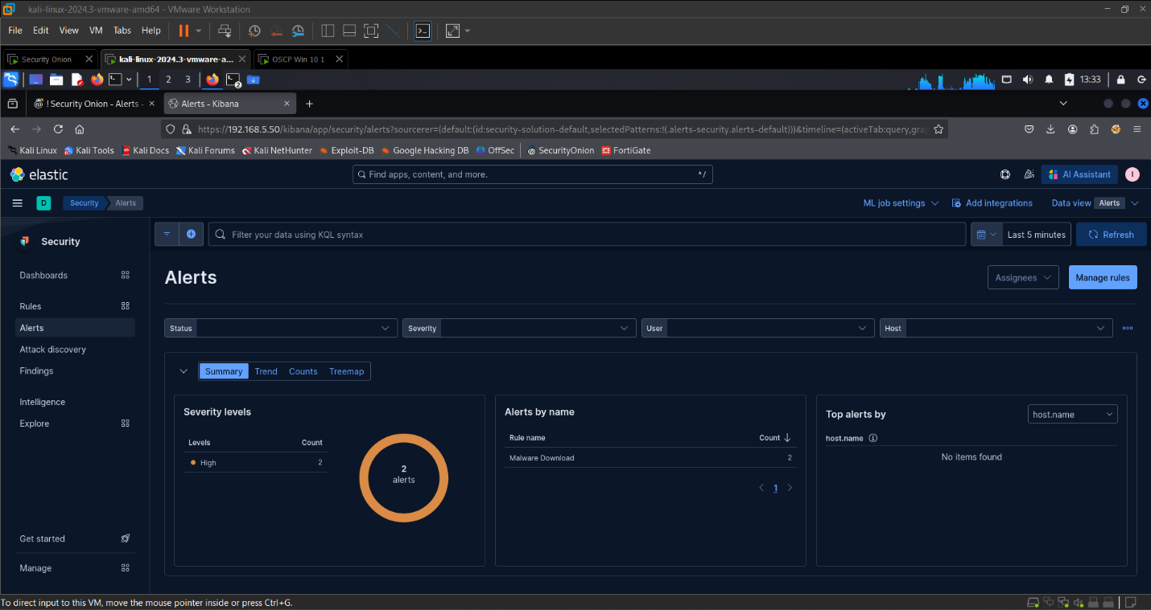

FortiGate Firewall Policy — Deny Policy Confirmed: 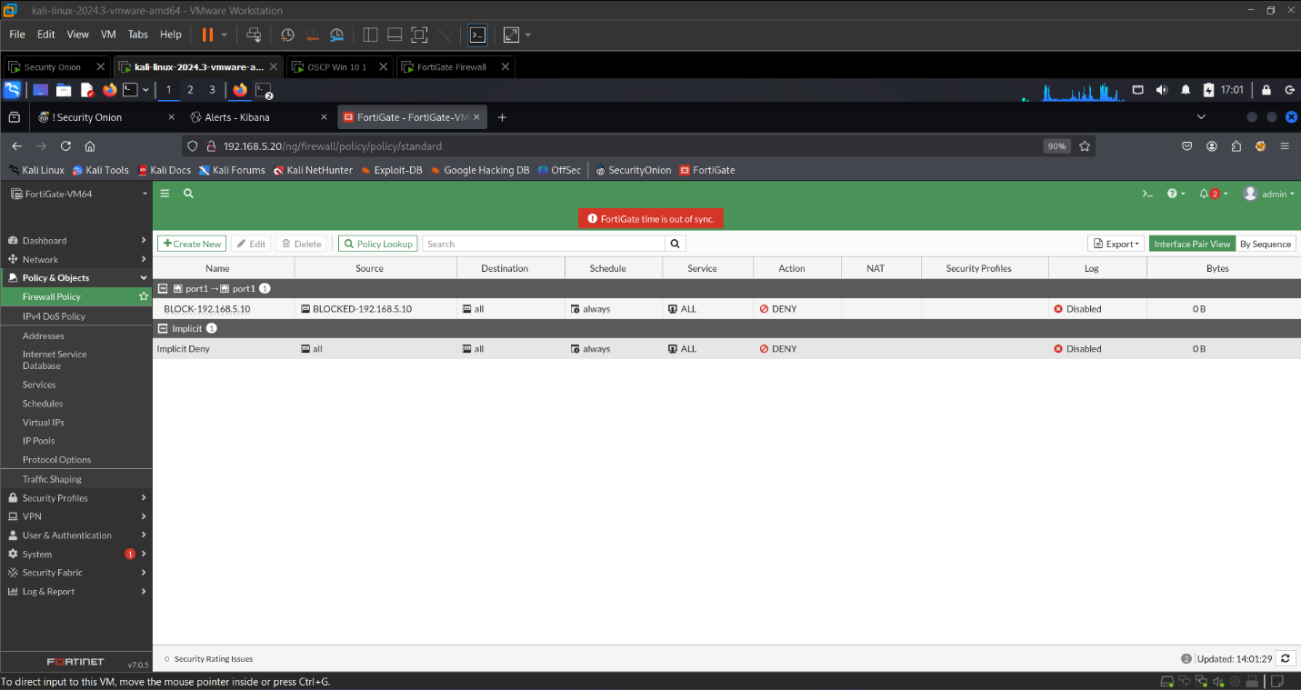

Telegram — MALWARE DETECTED Alert: 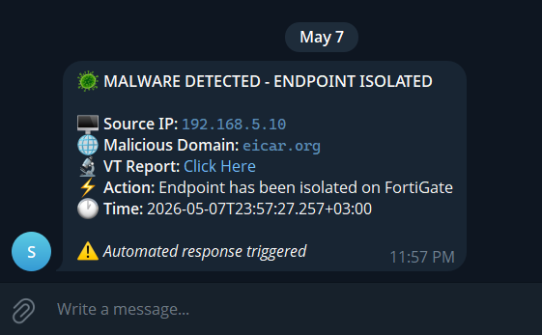

Gmail — MALWARE DETECTED Alert: 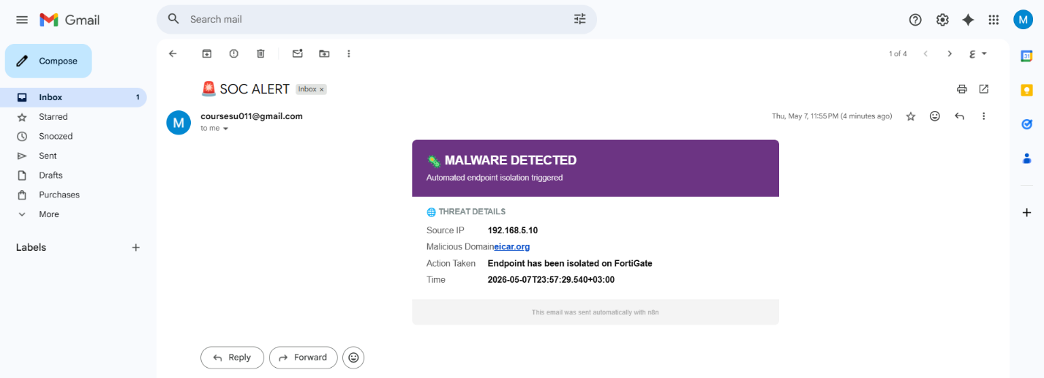
Kibana — SSH Scan Detected Alert: 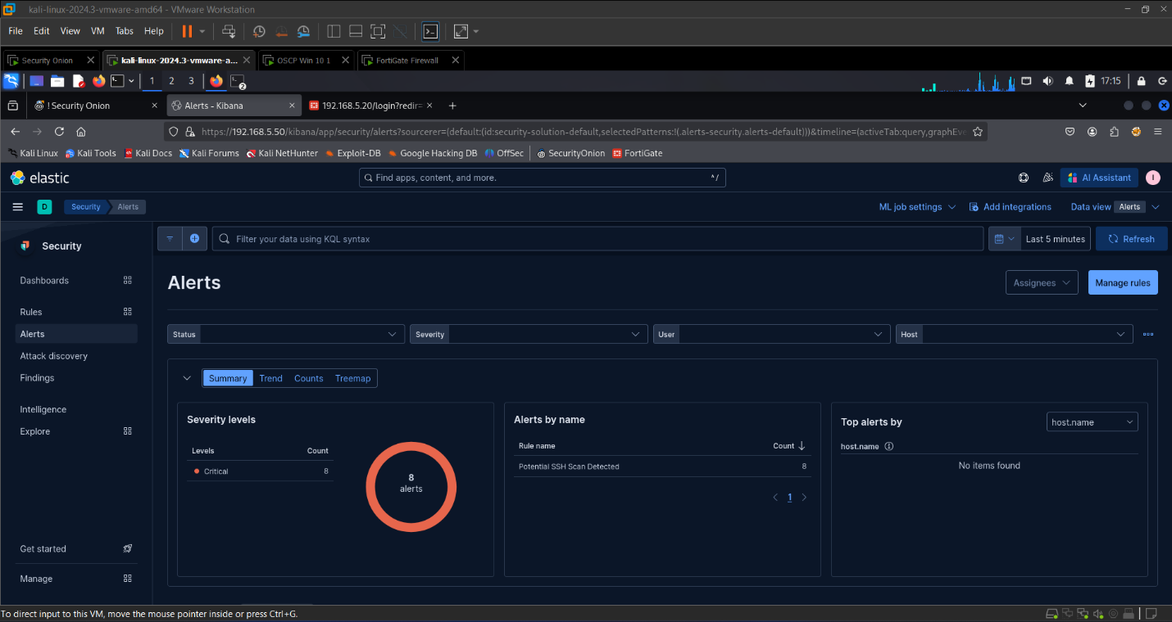
FortiGate — Endpoint Isolation Policy Applied: 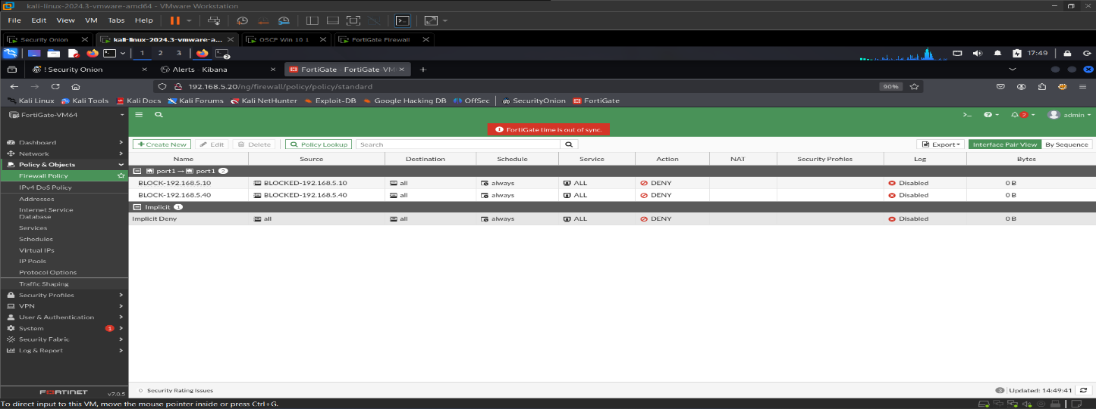

Telegram — NETWORK ATTACK DETECTED Alert: 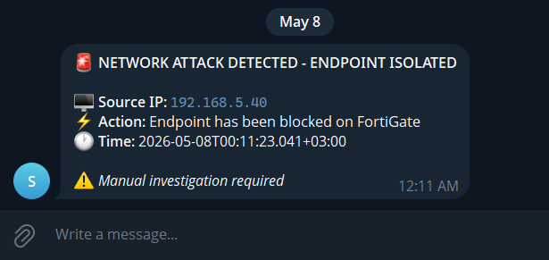

Telegram — REPEAT ATTACKER DETECTED Alert: 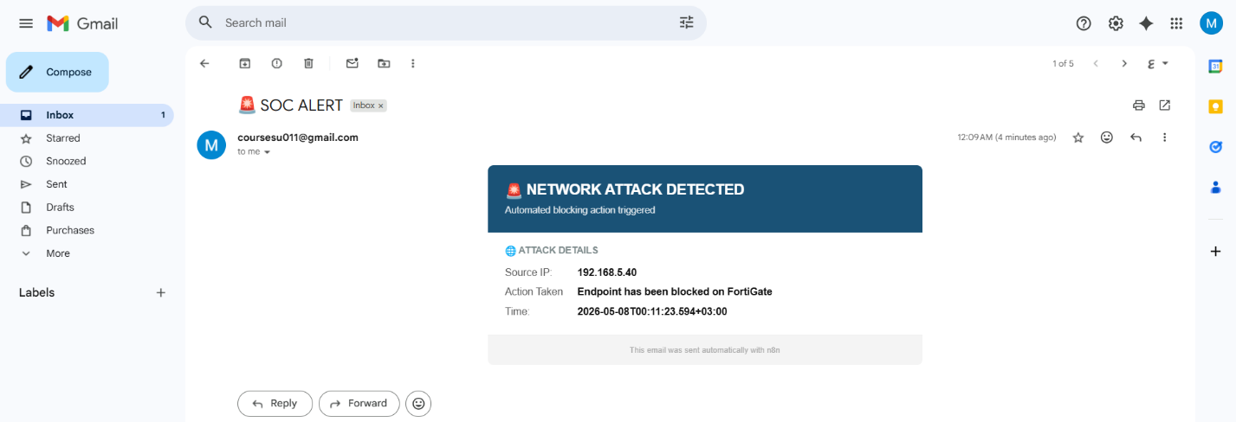

7. Hardware Used & Cost

Component | Specification
CPU | Intel Core i5-8250U — a standard laptop processor
RAM | 32 GB
Storage | 150 GB SSD
Total Software Cost | £0 — every tool used is free and open source

The key point:
Enterprise SOC software (Splunk, Cortex XSOAR) costs thousands of pounds per year. This project achieves the same core functions at zero cost, running on hardware most students already own.

8. What Makes This Project Different

Feature | Other Open-Source Labs | This Project
End-to-end automation | Partial — stops at alert | Full — detect, enrich, block, notify
Real-time attack simulation | Static log files | Live simulated attacks
Network enforcement (firewall blocking) | Rarely included | FortiGate + iptables
Multi-source threat intelligence | Single source | AbuseIPDB + VirusTotal + GreyNoise + URLScan.io
Case management | Manual | Automatic TheHive case creation
Duplicate suppression | Not included | Built-in across all 3 workflows
Cost | Free | Free

9. Summary

The project in one paragraph:
I built a fully automated digital security center using only free software that runs on a normal laptop. It watches a computer network around the clock, detects hackers and malware automatically, checks suspicious IPs and URLs against global threat databases, blocks confirmed threats at the firewall level, creates structured incident reports, and sends instant alerts to the analyst via Telegram and Gmail — all without any human needing to click a single button. The whole thing costs nothing in software licenses and can be set up by anyone.

